Spellings! Week 4

Please practise at home and be ready for a test next Friday! Ways you can practise spellings:
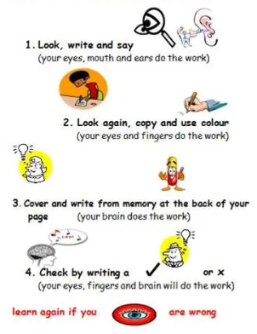
Year 1 Year 2
day please
play eating
May each
hay reach
say * great *

