Spellings! Week 2
Please practise at home and be ready for a test next Friday! Ways you can practise spellings:
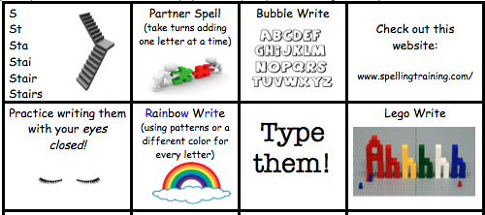
Use chalk outside.

Year 1 Year 2
a door
at floor
as jaw
an claw
and more

