Spellings! Autumn 2
Be prepared for Friday 6th November 2026
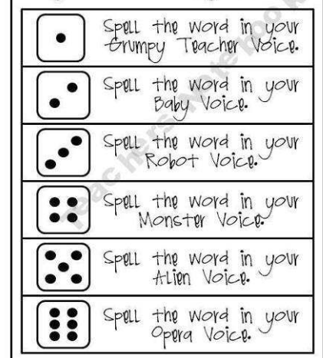
Year 1 Year 2
ear torches
hear dresses
fear benches
near quizzes
beard foxes

