Religious Education
The sequence of learning EYFS to Year 6

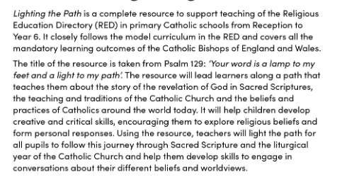
Religion Curriculum Intent

The year groups that will be learning from the RED curriculum will learn about the following branches, knowledge lenses and ways on knowing.

1. The six branches

The model curriculum has six annual themes, or branches, which map onto the six half terms of the school year. In each one, children study the Bible and learn about the Catholic worldview lived out in the Catholic Church. They reflect on what this learning means for their lives. The branches follow the liturgical cycle of the Church’s year, enabling schools to make links with the key aspects of the Catholic life of the school. The spiral structure of the curriculum enables children to build up layers of knowledge, deepening them each year through a growing understanding of scripture, enriched by the Christian tradition of art and music. Knowledge steps ensure progression and allow children to reflect on what their learning means for them.

Branch 1: Creation and covenant
In this branch, children encounter Bible texts where God creates and calls people. Children will explore the Christian belief that everything comes from God through the texts of the Book of Genesis and the reflective thoughts of the Psalms and explore how these texts differ from scientific knowledge. Children will hear accounts of God’s love for people expressed in the covenants (promises) found in the Old Testament.

Branch 2: Prophecy and promise
Linking with the Advent season, this branch teaches the mystery of the birth of Jesus, the Messiah, promised by God. Children will also learn how Christians read the stories of the prophets of the Old Testament and discern through the teaching within these stories points to a fulfilment of God’s promise in Jesus.

Branch 3: Galilee to Jerusalem
In this branch, children will learn about the ministry of Jesus and travel with different gospel writers as they hear accounts of Jesus’ life, listen to parables and learn how Jesus’ teaching underpins Christian beliefs and actions through the work of the Catholic Church today.

Branch 4: Desert to garden
Children study the liturgical season of Lent in this branch, the events of Holy Week, culminating in the death of Jesus on the Cross. The branch ends in the Garden of the Resurrection, where children will learn about the risen Jesus and the centrality of this event to Christian life.

Branch 5: To the ends of the earth
In this branch, children will hear about the events that flow from the Resurrection and Ascension of Jesus, the actions of the apostles and the establishment of the early Church. They will make links between the liturgy, sacraments, and structures of the Catholic Church today and its foundations in the world of the apostles.

Branch 6: Dialogue and encounter

In this branch, children will learn about Christianity as a global religion. They will encounter different faiths and learn how all people can work together to promote the common good.

The knowledge lenses
The RED sets out the areas of study children will “look at” in six knowledge lenses. Four lenses look at the study of Catholicism (hear, believe, celebrate, live), and two explore different religious and religious worldviews (dialogue and encounter).

The Ways of Knowing

The three Ways of Knowing, understand, discern and respond, set out the different skills children should acquire as they study RE. They focus on critical thinking and personal assimilation, as well as remembering information.

Each year group will have the ways of knowing helpers on display and they will be embedded into the whole school curriculum.



