Logging into Microsoft Office to access Microsoft TEAMS - Lower Juniors

- Search for Microsoft Office (Microsoftonline.com)
Sign in to your account (microsoftonline.com)

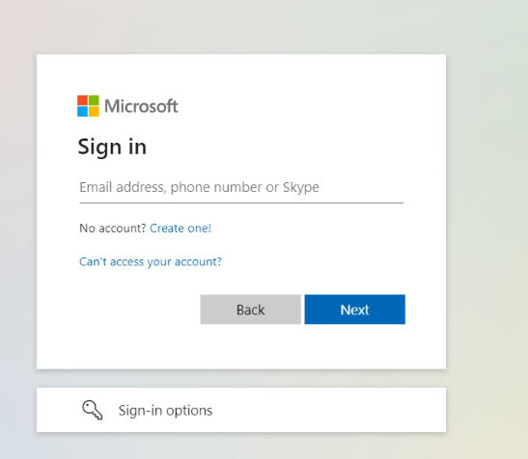
- Type in Microsoft account as stuck in reading records.
This should be your child’s first name then dot surname name.surname@stmarys-maidenhead.org.uk
e.g. Billy.jones@stmarys-maidenhead.org.uk
Or
First letter.Surname@stmarys-maidenhead.org.uk
e.g. o.jones@stmarys-maidenhead.org.uk

- Type in password which is on the sheet stuck in reading records. Most start with SMCP

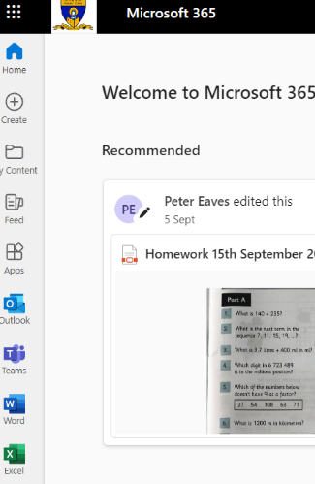
- When in Microsoft Office the homework should be visible as a PDF

- You can also download the Microsoft TEAMS app or click the TEAMS button which will link you to the Lower Juniors TEAM
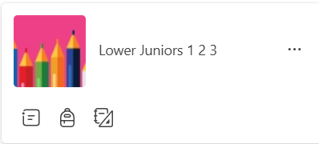

On the left side of the screen, click on General
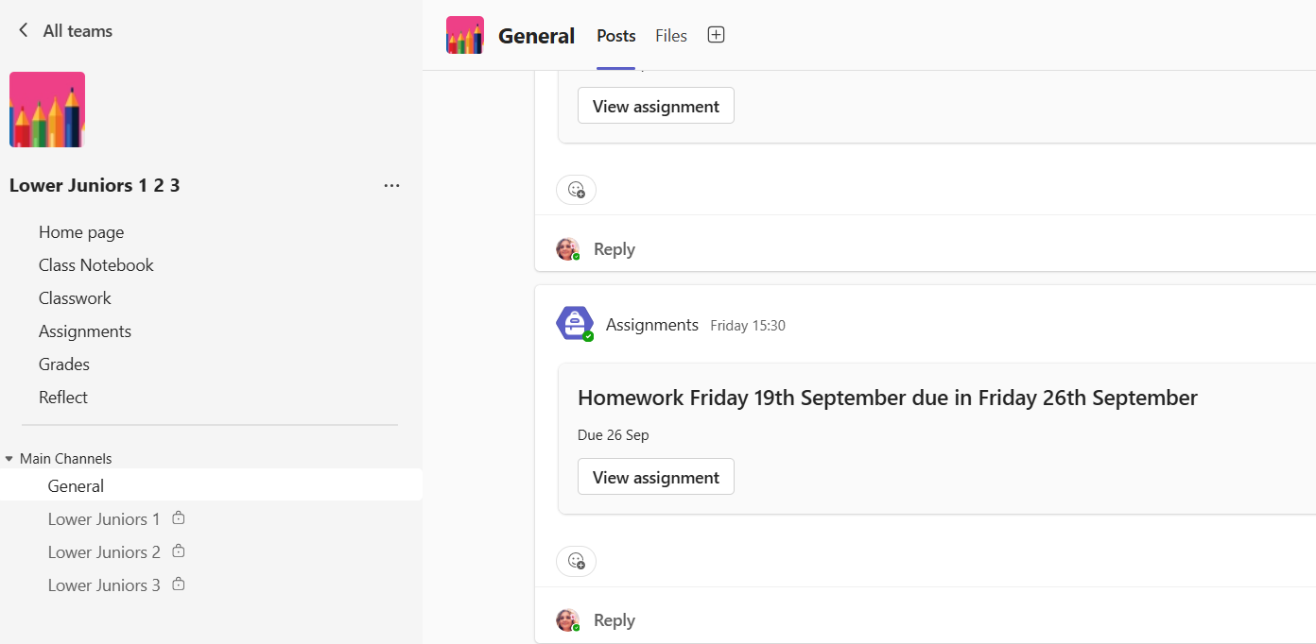

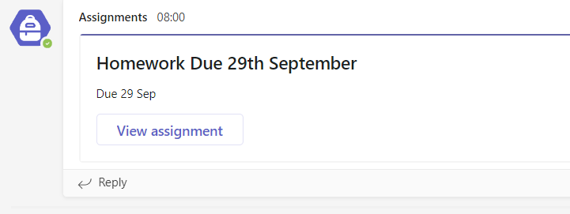
- This will show you in the general posts tab where the homework is. It can be printed out or simply answered in books.

