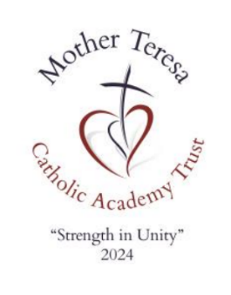
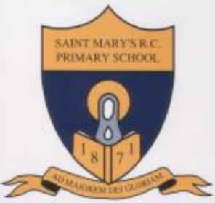
St Mary’s
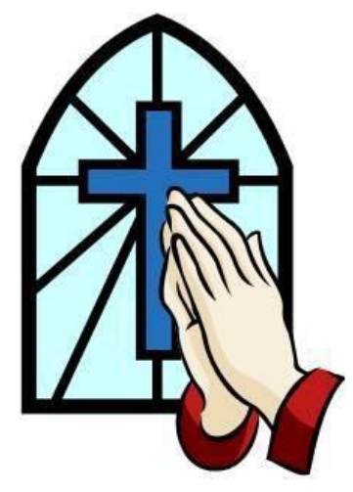
Catholic Primary School

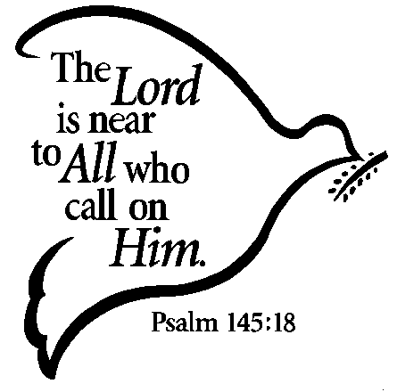

UPPER JUNIORS
PRAYER BOOK

MISSION STATEMENT

Learning and loving on our journey with Jesus
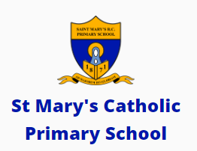

To the greater glory of God

What is prayer?
We pray when we talk and listen to God.
There are many different prayers we can use.
We can pray privately on our own or we can pray with others in a group.
We can pray within our family or with our friends.

Where can we pray?
We can pray anywhere: in church, at home, at school or any other place such as while travelling or waiting somewhere.
God is always ready to listen and talk to us.
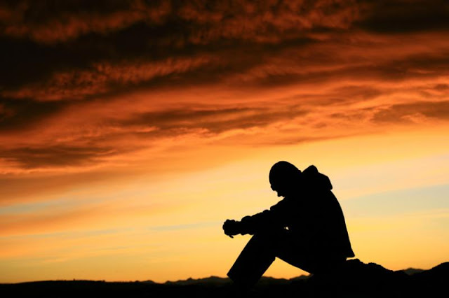

Sign of the Cross
The sign of the cross is our most special Christian sign. We make the sign of the cross at the beginning and end of many things we do.
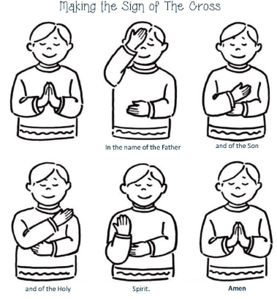

In the name of the Father and of the Son and of the Holy Spirit.
Amen

Hail Mary

The first part of the Hail Mary was said for the first time by the Angel Gabriel. The second part was said by Elizabeth when Mary went to visit her.

Hail Mary, full of grace, the Lord is with thee.
Blessed art thou amongst women,
and blessed is the fruit of thy womb, Jesus.
Holy Mary, Mother of God,
pray for us sinners now and at the hour of our death.
Amen
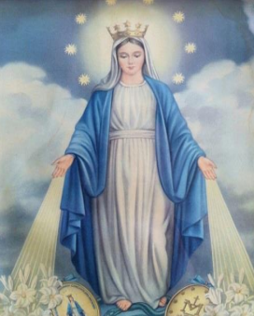

Our Father

When one of the disciples asked Jesus how to pray, He taught us the Our Father prayer.

Our Father,
Who art in heaven,
hallowed be Thy name;
Thy kingdom come;
Thy will be done on earth as it is in heaven.
Give us this day our daily bread;
and forgive us our trespasses
as we forgive those who trespass against us;
and lead us not into temptation,
but deliver us from evil.
Amen
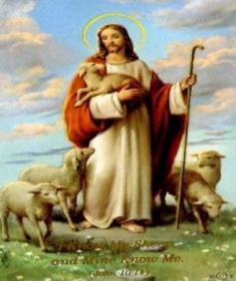

Our School Prayer

This is our school,
Let peace live here.
Let the rooms be full of happiness.
Let love be all around;
Love of one another,
Love of all people
And love of life and living.
Let us remember
That as many hands build a house;
So many hearts make a school.
Amen



Morning Prayer


Jesus, Lord, we wish to praise you
and to offer you this day,
all our joys and all our sorrows,
all our work and all our play.
Bless our friends and school companions,
help us all to grow like you,
teach us how to love each other,
make us care in all we do.
Amen

Prayer before lunch
Bless us, O Lord,
as we sit together,
Bless the food we eat today.
Bless the hands that made the food
Bless us, O Lord.
Amen

Prayer at the end of the day
May the Lord bless us
all the days of our lives.
May his face always shine upon us.
May he look upon us with kindness
and give us everlasting peace.
Amen

Prayer for Peace
God our Father,
lover of all nations, we pray for peace:
peace in our hearts and in our homes,
peace among nations and in our world.
Amen



Glory Be

In this prayer, we praise the Holy Trinity: God the Father, God the Son and God the Holy Spirit.

Glory be to the Father,
and to the Son,
and to the Holy Spirit,
as it was in the beginning,
is now, and ever shall be,
world without end.
Amen
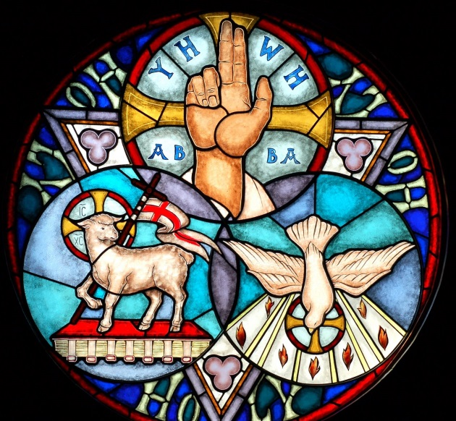

Prayer to my Guardian Angel

God gave each one of us an angel to look after us. We cannot see him but we can pray to him. This is a prayer to your Guardian angel.

Angel of God
my Guardian dear,
to whom God’s love commits me here.
Ever this day be at my side
to light and guard,
to rule and guide.
Amen

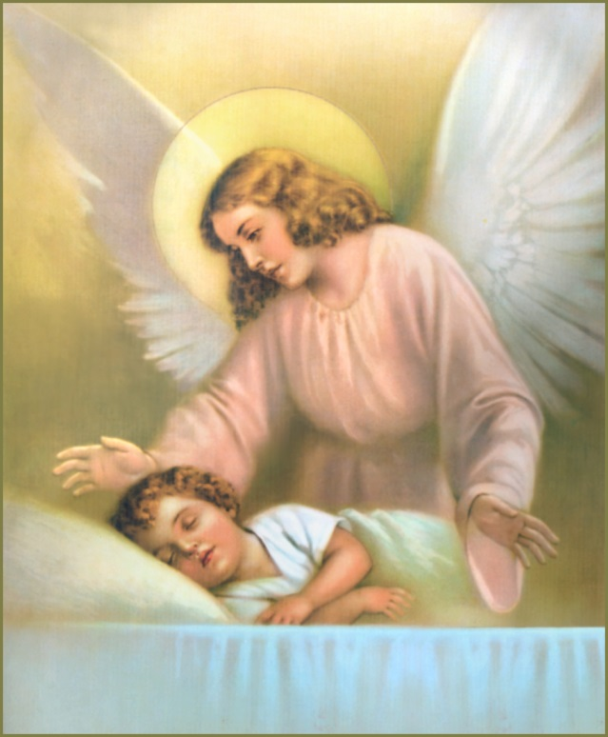

Eternal Rest

In this prayer, we pray for all those people who have died.

Eternal rest
Grant unto them, O Lord,
And let perpetual light shine upon them.
May they rest in peace.
Amen

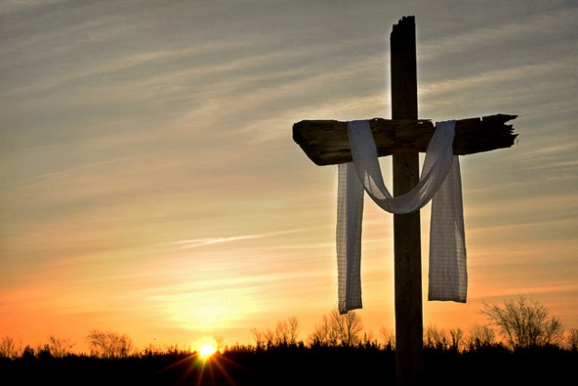

Act of Contrition
We say this prayer to show God we are sorry for the times we have not done the right thing.

O my God,
Because you are so good
I am very sorry that I have sinned against you
and by the help of your grace
I will not sin again.
Amen

The Confeteor
This is another prayer we say to show God we are sorry. It is said during Mass.

I confess to almighty God
and to you my brothers and sisters,
that I have greatly sinned,
in my thoughts and in my words,
in what I have done and in what I have failed to do,
through my fault, through my fault, through my most grievous fault;
therefore I ask blessed Mary, ever-Virgin,
all the Angels and Saints,
and you, my brothers and sisters,
to pray for me to the Lord our God.
Amen


The Angelus
This prayer reminds us of when the Angel Gabriel was sent to Mary to tell her that she was going to have baby Jesus - the son of God. Some people say the Angelus three times a day: morning, noon and evening.

The Angel of the Lord declared unto Mary:
And she conceived of the Holy Spirit.
Hail Mary, full of grace …

Behold the handmaid of the Lord:
Be it done to me according to thy word.
Hail Mary, full of grace …

And the Word was made flesh:
And dwelt among us.
Hail Mary, full of grace …

Pray for us, O holy Mother of God.
That we may be made worthy of the promises of Christ.

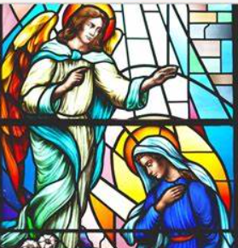

The Memorare
The Memorare is a prayer to help us remember how important and special Mary is to us in our lives.

Remember, O most loving Virgin Mary,
that it is a thing unheard of,
that anyone ever had recourse to your protection,
implored your help,
or sought your intercession,
and was left forsaken.

Filled therefore with confidence in your
goodness
I fly to you, O Mother, Virgin of virgins.
To you I come, before you I stand,
a sorrowful sinner.

Despise not my poor words,
O Mother of the Word of God,
but graciously hear
and grant my prayer.
Amen

The Rosary
The Rosary is a prayer to Mary. It consists of 5 decades, each beginning with a short thought about one of the mysteries. In each decade we say 1 Our Father, 10 Hail Marys and 1 Glory Be. We can use the Rosary beads to help counting. There are 4 sets of Mysteries.

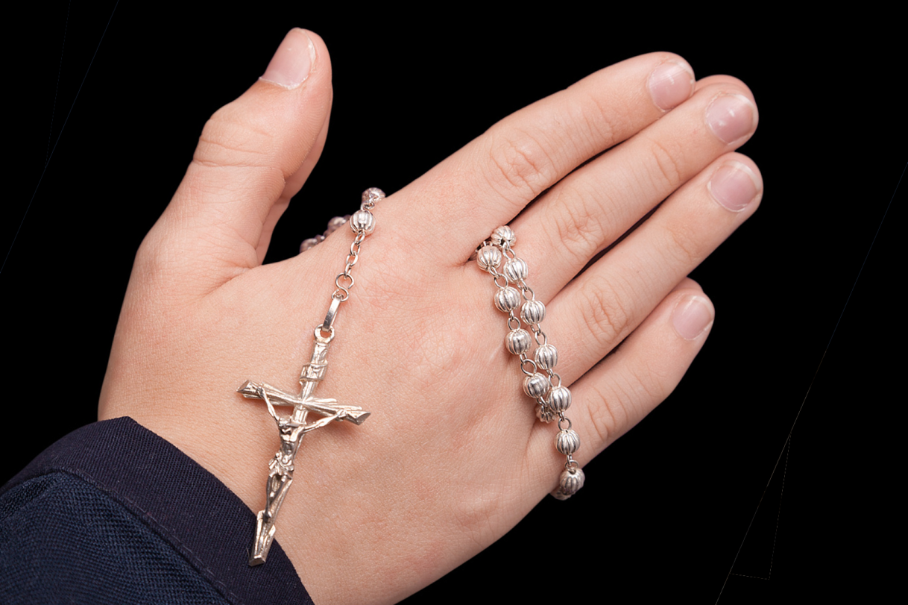
THE JOYFUL MYSTERIES
1. The Annunciation to Mary.
2. The Visitation to Elizabeth.
3. The Nativity (Birth of Jesus).
4. The Presentation of Jesus in the Temple.
5. The finding of Jesus in the Temple.
THE LUMINOUS MYSTERIES
1. The Baptism of Jesus in the River.
2. The Wedding at Cana.
3. The Proclamation of God’s Kingdom.
4. The Transfiguration of Jesus.
5. The Institution of the Eucharist.
THE SORROWFUL MYSTERIES
1. The Agony in the Garden.
2. The Scourging at the Pillar.
3. The Crowning with Thorns.
4. The Carrying of the Cross.
5. The Crucifixion.
THE GLORIOUS MYSTERIES
1. The Resurrection of Jesus.
2. The Ascension of Jesus.
3. The Coming of the Holy Spirit.
4. The Assumption of Mary.
5. The Crowning of Mary.
Stations of the Cross
In the Stations of the Cross we walk with Jesus carrying the cross to Mount Calvary. We think of what he went through when he suffered and died to save us from sin.

1. Jesus is condemned to death.
2. Jesus accepts his cross.
3. Jesus falls for the first time.
4. Jesus meets his mother
5. Simon helps carry the cross.
6. Veronica wipes the face of Jesus.
7. Jesus falls for the second time.
8. Jesus speaks to the women.
9. Jesus falls for the third time.
10. Jesus stripped of his garments.
11. Jesus is nailed to the cross.
12. Jesus dies on the cross.
13. Jesus is taken down from the cross.
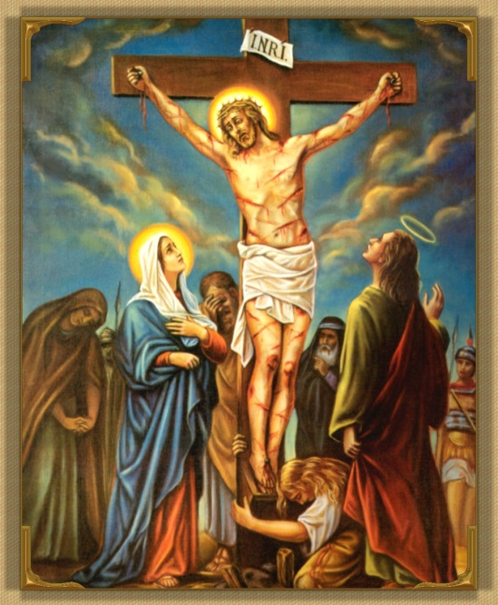
14. Jesus is laid in the tomb.

The Magnificat
This is Mary’s special prayer of praise to God. She prayed this when she was told she was going to be the mother of Jesus.

My soul glorifies the Lord,
My spirit rejoices in God, my Saviour.
He looks on his servant in her loneliness;
henceforth all ages will call me blessed.
The Almighty works marvels for me.
Holy his name!

His mercy is from age to age,
on those who fear him.
He puts forth his arm in strength
and scatters the proud-hearted.
He casts the mighty from their thrones
and raises the lowly.

He fills the starving with good things,
sends the rich away empty.
He protects Israel, his servant,
remembering his mercy,
the mercy promised to our fathers,
to Abraham and his sons forever.

Nunc Dimittis
This prayer was said by Simeon when he saw Jesus in the temple. Simeon was an old man who desperately wanted to see the Messiah. When Mary and Joseph brought Jesus into the temple, Simeon was overjoyed and prayed this prayer.

At last, all powerful Master,
you give leave to your servant to go in peace,
according to your promise.
For my eyes have seen your salvation
which you have prepared for all nations,
the light to enlighten the Gentiles
and give glory to Israel, your people.

Give praise to the Father almighty,
to his Son, Jesus Christ, the Lord,
to the Spirit, who dwells in our hearts,
both now and forever.
Amen
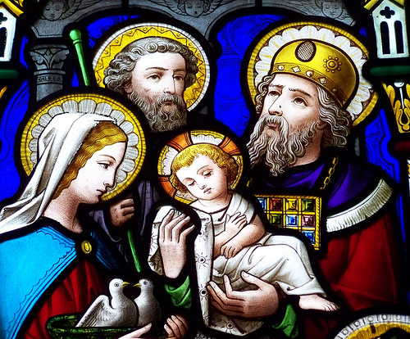

The Benedictus
Elizabeth’s husband, Zechariah, prayed this prayer of praise to God when he found out that he was to have a son, John the Baptist.

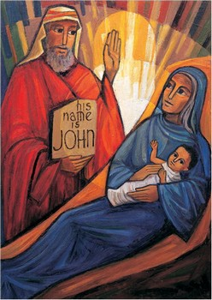
Blessed be the Lord, the God of Israel!
He has visited his people and redeemed them.
He has raised up for us a mighty saviour
In the house of David his servant,
As he promised by the lips of holy men,
Those who were his prophets from of old.
A saviour who would free us from our foes,
From the hands of all who hate us.
So his love for our fathers is fulfilled
And his holy covenant remembered.
He swore to Abraham our father to grant us,
that free from fear, and saved from the hands of our foes,
we might serve him in holiness and justice
all the days of our life in his presence.
As for you, little child,
you shall be called a prophet of God, the Most High.
You shall go ahead of the Lord
To prepare his ways before him.
To make known to his people their salvation
Through forgiveness of all their sins,
The loving-kindness of the heart of our God
Who visits us like the dawn from on high.
He will give light to those in darkness,
Those who dwell in the shadow of death,
And guide us into the way of peace.
Glory be to the Father
and to the Son
and to the Holy Spirit,
as it was in the beginning, is now,
and ever shall be,
world without end.
Amen

Prayer to the Holy Spirit
In Confirmation, we receive the gifts of the Holy Spirit. We ask the Holy Spirit to come upon us.

Come, Holy Spirit,
fill the hearts of your faithful,
and enkindle in them the fire of your love.
Send forth your Spirit
and they shall be created.
And you shall renew
the face of the earth.

O God, who has taught the hearts of the faithful
by the light of the Holy Spirit,
grant that by the gift of that same Spirit
we may be always truly wise
and ever rejoice in his consolation.
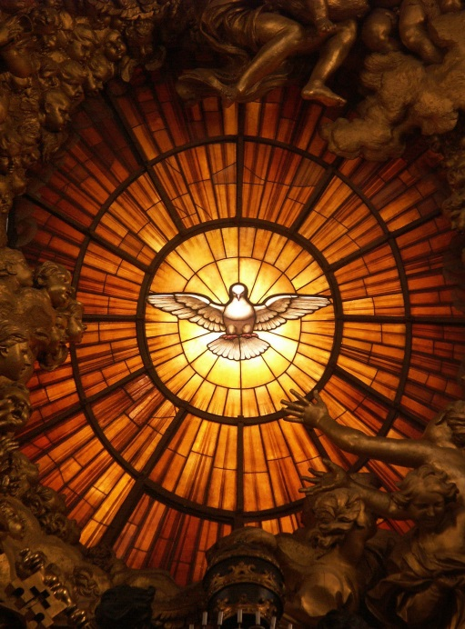
Amen

Apostles Creed
The creed is a statement which lists all that we believe in as Christians. The word “Creed” means “I believe”.

I believe in God, the Father almighty,
Creator of heaven and earth,
and in Jesus Christ, his only Son, our Lord, who was conceived by the Holy Spirit,
born of the Virgin Mary,
suffered under Pontius Pilate,
was crucified, died and was buried;
he descended into hell;
on the third day he rose again from the dead;
he ascended into heaven,
and is seated at the right hand of God the Father almighty;
from there he will come to judge the living and the dead.
I believe in the Holy Spirit, the Holy Catholic Church,
the communion of saints, the forgiveness of sins,
the resurrection of the body, and life everlasting.
Amen

The Examen



