

St Mary’s

Catholic Primary School

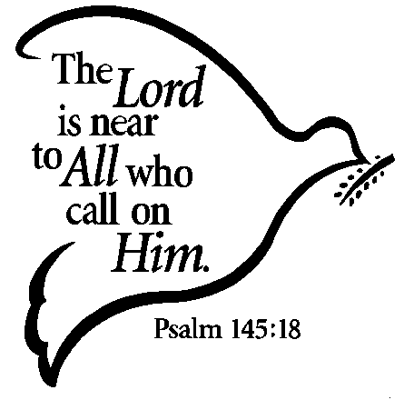

LOWER JUNIOR
PRAYER BOOK

MISSION STATEMENT

Learning and loving on our journey with Jesus
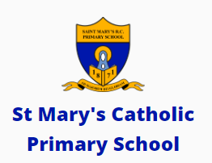

To the greater glory of God

What is prayer?
We pray when we talk and listen to God.
There are many different prayers we can use.
We can pray privately on our own or we can pray with others in a group.
We can pray within our family or with our friends.

Where can we pray?
We can pray anywhere: in church, at home, at school or any other place such as while travelling or waiting somewhere.
God is always ready to listen and talk to us.


Sign of the Cross
The sign of the cross is our most special Christian sign. We make the sign of the cross at the beginning and end of many things we do.
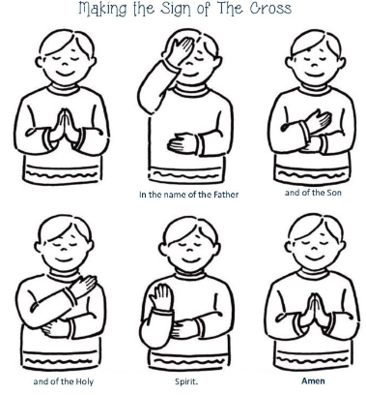

In the name of the Father and of the Son and of the Holy Spirit.
Amen

Hail Mary

The first part of the Hail Mary was said for the first time by the Angel Gabriel. The second part was said by Elizabeth when Mary went to visit her.

Hail Mary, full of grace, the Lord is with thee.
Blessed art thou amongst women,
and blessed is the fruit of thy womb, Jesus.
Holy Mary, Mother of God,
pray for us sinners now and at the hour of our death.
Amen
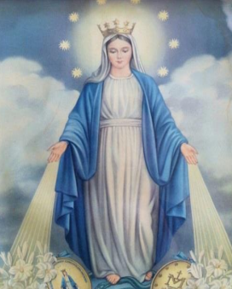

Our Father

When one of the disciples asked Jesus how to pray, He taught us the Our Father prayer.

Our Father,
Who art in heaven,
hallowed be Thy name;
Thy kingdom come;
Thy will be done on earth as it is in heaven.
Give us this day our daily bread;
and forgive us our trespasses
as we forgive those who trespass against us;
and lead us not into temptation,
but deliver us from evil.
Amen
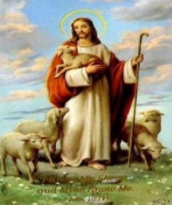

Our School Prayer

This is our school,
Let peace live here.
Let the rooms be full of happiness.
Let love be all around;
Love of one another,
Love of all people
And love of life and living.
Let us remember
That as many hands build a house;
So many hearts make a school.
Amen

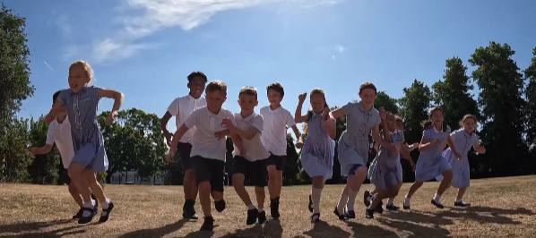

Morning Prayer


Jesus, Lord, we wish to praise you
and to offer you this day,
all our joys and all our sorrows,
all our work and all our play.
Bless our friends and school companions,
help us all to grow like you,
teach us how to love each other,
make us care in all we do.
Amen

Prayer before lunch
Bless us, O Lord,
as we sit together,
Bless the food we eat today.
Bless the hands that made the food
Bless us, O Lord.
Amen

Prayer at the end of the day
May the Lord bless us
all the days of our lives.
May his face always shine upon us.
May he look upon us with kindness
and give us everlasting peace.
Amen

Prayer for Peace
God our Father,
lover of all nations, we pray for peace:
peace in our hearts and in our homes,
peace among nations and in our world.
Amen



Glory Be

In this prayer, we praise the Holy Trinity: God the Father, God the Son and God the Holy Spirit.

Glory be to the Father,
and to the Son,
and to the Holy Spirit,
as it was in the beginning,
is now, and ever shall be,
world without end.
Amen
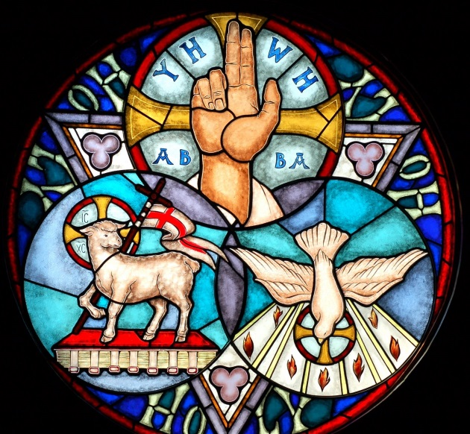

Prayer to my Guardian Angel

God gave each one of us an angel to look after us. We cannot see him but we can pray to him. This is a prayer to your Guardian angel.

Angel of God
my Guardian dear,
to whom God’s love commits me here.
Ever this day be at my side
to light and guard,
to rule and guide.
Amen

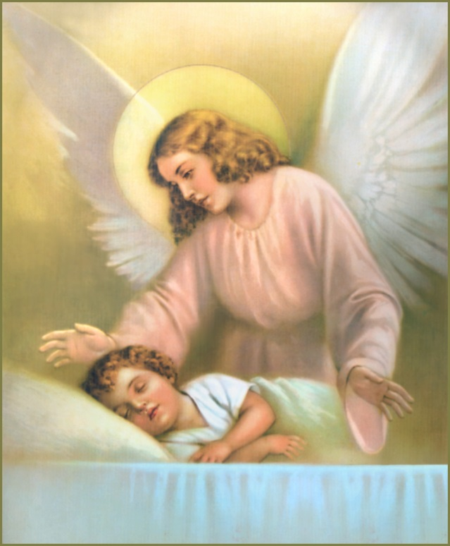

Eternal Rest

In this prayer, we pray for all those people who have died.

Eternal rest
Grant unto them, O Lord,
And let perpetual light shine upon them.
May they rest in peace.
Amen

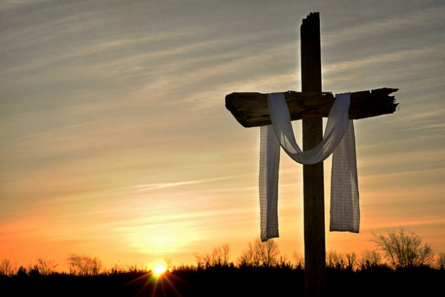

Act of Contrition
We say this prayer to show God we are sorry for the times we have not done the right thing.

O my God,
Because you are so good
I am very sorry that I have sinned against you
and by the help of your grace
I will not sin again.
Amen

The Confeteor
This is another prayer we say to show God we are sorry. It is said during Mass.

I confess to almighty God
and to you my brothers and sisters,
that I have greatly sinned,
in my thoughts and in my words,
in what I have done and in what I have failed to do,
through my fault, through my fault, through my most grievous fault;
therefore I ask blessed Mary, ever-Virgin,
all the Angels and Saints,
and you, my brothers and sisters,
to pray for me to the Lord our God.
Amen


The Angelus
This prayer reminds us of when the Angel Gabriel was sent to Mary to tell her that she was going to have baby Jesus - the son of God. Some people say the Angelus three times a day: morning, noon and evening.

The Angel of the Lord declared unto Mary:
And she conceived of the Holy Spirit.
Hail Mary, full of grace …

Behold the handmaid of the Lord:
Be it done to me according to thy word.
Hail Mary, full of grace …

And the Word was made flesh:
And dwelt among us.
Hail Mary, full of grace …

Pray for us, O holy Mother of God.
That we may be made worthy of the promises of Christ.

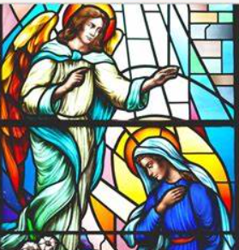

The Examen



