Logging into Microsoft Office to access Microsoft TEAMS

- Search for Microsoft Office (Microsoftonline.com)
Sign in to your account (microsoftonline.com)

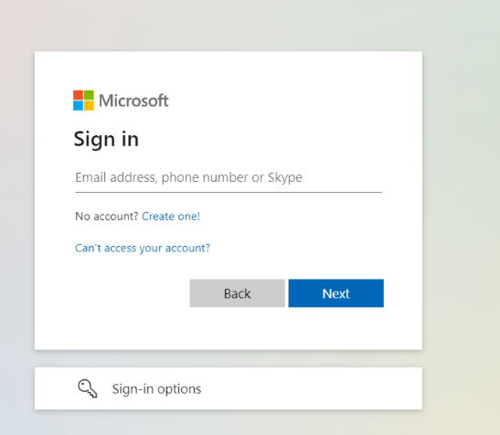
- Type in Microsoft account as stuck in reading records.
This should be your child’s first name then dot surname name.surname@stmarys-maidenhead.org.uk
e.g. Billy.jones@stmarys-maidenhead.org.uk

- Type in password which is on the sheet stuck in reading records. Most start with SMCP

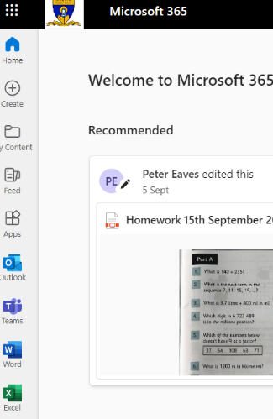
- When in Microsoft Office the homework should be visible as a PDF


- You can also download the Microsoft TEAMS app or click the TEAMS button which will link you to the Upper Junior TEAM

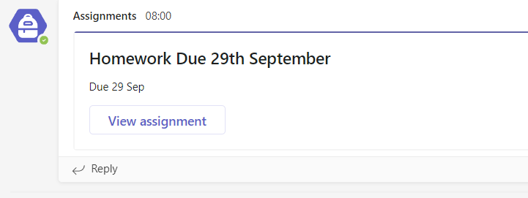
- This will show you in the general posts tab where the homework is. It can be printed out or simply answered in books.

